32.53: a) 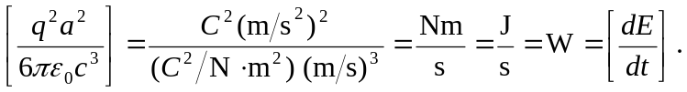
b) For a proton moving in a circle, the acceleration can be rewritten:
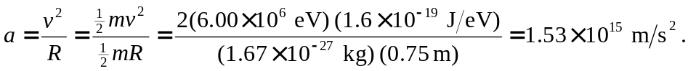
The rate at which it emits energy because of its acceleration is:
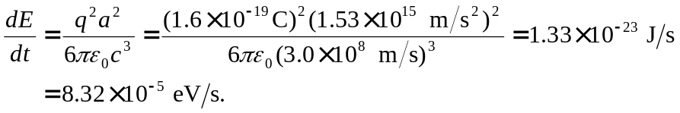
So the fraction of its energy that it radiates every second is:
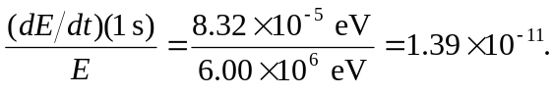
c) Carrying out the same calculations as in part (b), but now for an electron at the same speed and radius. That means the electron’s acceleration is the same as the proton, and thus so is the rate at which it emits energy, since they also have the same charge. However, the electron’s initial energy differs from the proton’s by the ratio of their masses:
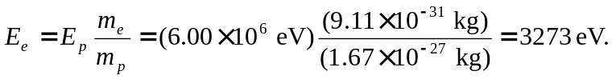
So the fraction of its energy that it radiates every second is:
